Surname |  | Group No |  | Personal Tutor:
First Name |  | Discipline

UNIVERSITY OF BIRMINGHAM

School of Engineering

Experiment 1.5 - Pin-Jointed Truss

Safety
Make sure you know where the nearest fire exits are and what the evacuation procedure is.
Make sure you know where the nearest first aiders are located and what their phone numbers are. Do not operate the machinery unless you have been instructed to do so by the supervisor.

Learning outcomes
By the end of this experiment, you should hopefully:

• be able to calculate the internal forces in a pin-pointed truss subject to a set of external loading conditions

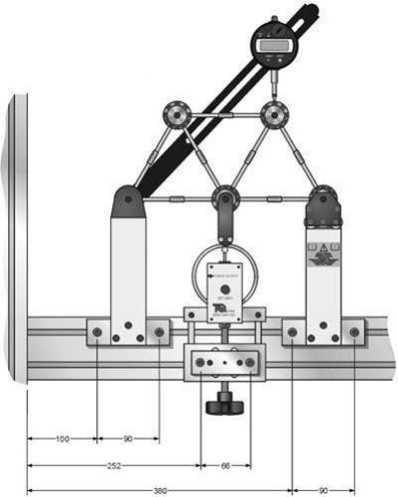
Figure 1: Pin-jointed frame including loading frame (units: mm)

EXPERIMENT
Examine the relevant equipment and observe the effect that varying the load has on the readings obtained from the strain gauges positioned on the truss’s members. Make sure the equipment is set up properly (this can be checked with the Teaching Assistant), then follow these steps:

❖ Reduce the load until there is little to no resistance when turning the load dial.
❖ Check the pin in the joint between members 1 and 2, it should be easy to move with little friction.
❖ If the pin binds adjust the load dial in a small increment either clockwise or anticlockwise and check
the pin again.
❖ If there is less resistance to the pin moving keep moving the dial in increments until the pin nearly moves freely.
❖ If the pin becomes stiffer move the dial in the opposite direction and repeat.

Once the above steps have been completed, the Truss is ready to be loaded and strain on its members can be measured:

o Apply loads in increments of 100 N up to a maximum of 500 N, recording the true memberstrain in Table 1. Make sure that you subtract the value of the strain gauge at a load of 0 N to “correct” the strain readings.
o Record the deflection of the girder under the dial gauge.
o Calculate the theoretical member forces for the framework with a load of 500 N.
o Compare the experimental and theoretical results.
o Plot a graph of Load (N) against Joint Deflection (mm) and comment on the resulting graph.
o Evaluate potential errors in the measurements and calculations performed.

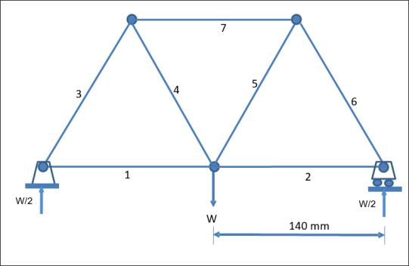

Figure 2: Labelled members on pin-jointed truss.

Table 1: True Member Strain (με)

Load (N) | Strain 1 μϵ | Strain 2 μϵ | Strain 3 μϵ | Strain 4 μϵ | Strain 5 μϵ | Strain 6 μϵ | Strain 7 μϵ
0 | 11 | 14 | 11 | 34 | 10 | 11 | 13
100 | 15 | 18 | 1 | 44 | 21 | 1 | 4
200 | 21 | 23 | -11 | 55 | 32 | -10 | -6
300 | 26 | 28 | -22 | 65 | 43 | -21 | -16
400 | 31 | 33 | -32 | 75 | 53 | -32 | -25
500 | 36 | 38 | -42 | 85 | 64 | -42 | -35

Subsequently, calculate the equivalent member forces for an applied load of 500 N and complete the
“Experimental Forces” column in Table 2. This requires using the measured strain, ε, to calculate the induced stress, σ, noting their relationship as per the material’s Young’s modulus, E, and that members are made from

steel:
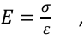 | 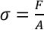 | , Es = 210 GNm−2

Where, the Young’s Modulus for steel is denoted by Es, F is the force acting through a given member and A is the cross-sectional area. Measure the diameter of the rods to calculate their cross-sectional area. Don’tforget to
include the measurement uncertainty (±0.01 mm):

Rod diameter = 6 mm
Member | Corrected Strain ($\mu\epsilon$) | Experimental Force (N) | Theoretical Force (N) | Error (%)
1 | $36-11 = 25 | 148.4 | 144.3 | 2.8%
2 | $38-14 = 24 | 142.5 | 144.3 | 1.2%
3 | $-42-11 = -53 | -314.7 | -288.7 | 9.0%
4 | $85-34 = 51 | 302.8 | 288.7 | 4.9%
5 | $64-10 = 54 | 320.6 | 288.7 | 11.0%
6 | $-42-11 = -53 | -314.7 | -288.7 | 9.0%
7 | $-35-13 = -48 | -285.0 | -288.7 | 1.3%
Table 3: Comparison of Experimental Force between Member 4 and Member 6
Load (N) | epsilon Member 4 (corrected) | F_E Member 4 (N) | epsilon Member 6 (corrected) | F_E Member 6 (N)
0 | 0 | 0.0 | 0 | 0.0
100 | 10 | 59.4 | -10 | -59.4
200 | 21 | 124.7 | -21 | -124.7
300 | 31 | 184.1 | -32 | -190.0
400 | 41 | 243.4 | -43 | -255.3
500 | 51 | 302.8 | -53 | -314.7

Finally:
❖ For members 4 and 6, plot a graph of load applied to the truss (N), on the horizontal axis, against Strain (με) measured (vertical axis).
❖ For members 4 and 6, plot a graph of the load applied to the truss (horizontal axis),against the
experimental force calculated to be acting within these members (vertical axis). ❖ Comment on the relationships observed and any anomalies in your graph.

You may wish to refer to the Theory section at the end of this lab sheet to aid in understanding the above calculations.
Graph
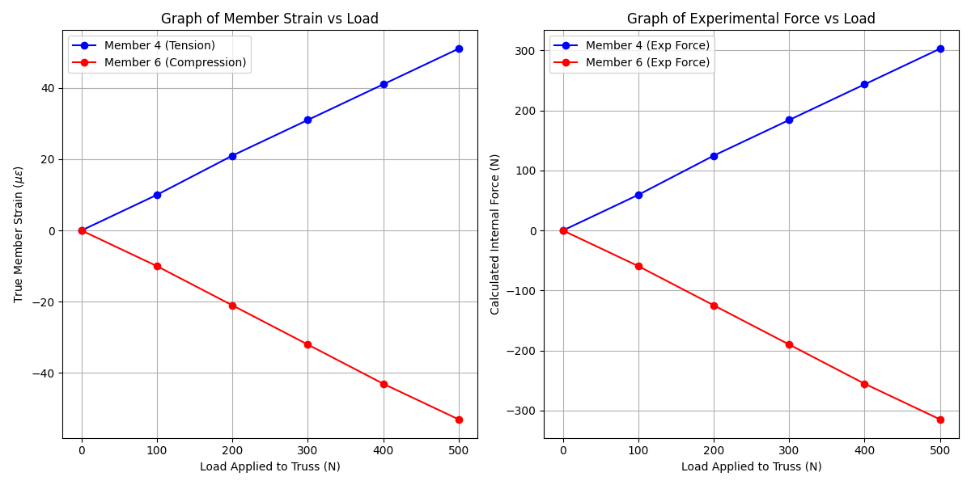

Comments on results obtained
1. Linearity and Relationships: The graphs plotted for Members 4 and 6 demonstrate a clear linear relationship between the applied load and the member strain (and consequently the internal force).
- Member 4 shows a positive linear gradient, confirming it is in Tension.
- Member 6 shows a negative linear gradient, confirming it is in Compression. This linearity validates Hooke's Law and the assumption that the truss behaves elastically under these loads.
2. Symmetry: The truss is symmetrical, and the results largely support this.
- Member 1 (148.4 N) and Member 2 (142.5 N) are very close in value.
- Member 4 (302.8 N) and Member 5 (320.6 N) are both in tension, though Member 5 deviates slightly more.
- Member 3 (-314.7 N) and Member 6 (-314.7 N) are identical in the experimental calculation, showing excellent symmetry in the compressive outer members.
3. Comparison with Theory: The experimental values align well with the theoretical predictions derived from the method of joints.
- The errors are generally low, with Members 1, 2, and 7 having errors under 3%.
- Members 3, 5, and 6 show slightly higher errors (9-11%). The experimental forces for these diagonal members are consistently higher (in magnitude) than theoretical predictions.
4. Potential Anomalies/Errors:
- Friction in Joints: The theoretical model assumes perfect frictionless pin joints. In reality, friction exists (as noted in the setup instructions where the pin had to be checked for binding). This friction can transfer moments and alter the distribution of forces, which may explain why the diagonal forces (3, 5, 6) are slightly higher than expected.
- Support Movement: If the roller support had friction, it might not have moved perfectly freely, inducing small horizontal reaction forces that strictly shouldn't be there in the theoretical model.

THEORY

For the structure to be in equilibrium, the reactions at the supports must be equal to the applied load, W. Since the supports are symmetrical about the loading point, each support must carry half of the applied load i.e. W/2.
Furthermore, as each of the pin joints are static, the resultant force acting on the pin must be zero, i.e. they are in equilibrium. Separating off-axis forces into their vertical and horizontal components, via trigonometry, then allows us to solve a vertical and horizontal equilibrium equation for the
forces acting on each pin joint and find the forces in each member.

Starting from the bottom left pin as it has a known support force:
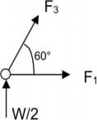
Solving the vertical components:

Hence, F3 = −
Then solve the horizontal components:
F1 + F3 cos 60 = 0 ℎence , F1 = 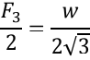

We can now move to the top left pin and repeat the process as we know the force in member 3:
Solving the vertical components:
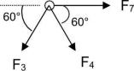
F3 sin 60 + sin 60 = 0 , ℎence = −F3 = Solving for the horizontal component:
F7 + F4 cos 60 − F3 cos 60 = 0 ℎence, 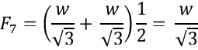

Since we know the structure is symmetrical, the forces in the members are:
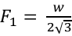 , 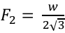 , F3 = − 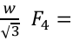 , F5 = , F6 = − , F7 = −

